|  |  |  |
| --- | --- | --- |
| bu-master-logo.gif | **BOSTON UNIVERSITY**  **FORENSIC ANTHROPOLOGY REPORT:**  **Case BU-35** | ForensicAnthropology.jpg |
|  | **Nicollette Appel, B.S.** |  |
|  | **4 May 2017** |  |

**DESCRIPTION OF REMAINS**

The remains consist of a nearly complete skeleton in good condition (Table 1 and Figures 1 and 2). All portions of the skeleton are represented, with only small elements or fragments missing. No cleaning or preparation was necessary. Reconstruction was undertaken for the cranium and for the mandible.

**MINIMUM NUMBER OF INDIVIDUALS**

The MNI = 1. A minimum of one individual is present, due to provenience, lack of duplication, consistency in size, development and broad taphonomic history, articulation, pair-matching, and refitting.

**SEX**

Male. Using the pelvic criteria described by Phenice (1969) and Buikstra and Ubelaker (1994), this area of the skeleton scores as male in most characteristics (ventral arc, ischiopubic ramus ridge, greater sciatic notch, and lack of preauricular sulcus). The subpubic concavity scores more ambiguous. The skull scores as more male for the mental eminence and more ambiguous for the nuchal crest and mastoid process, following the criteria of Buikstra and Ubelaker (1994). All characteristics could not be scored due to lack of cranial regions. The left and right clavicles did not have a rhomboid fossa; therefore this trait cannot be used to provide a sex estimation based on Rogers *et al*. (2000) criteria. Following Vance *et al.* (2011),the right humerus scores male for one characteristic (trochlear extension), and ambiguous for the other two characteristics (olecranon fossa shape, and angle of the medial epicondyle), and the overall score (8) indicates male.

A *FORDISC 3.1* analysis (Jantz and Ousley 2005) of 37 postcranial measurements using Black and White, male and female populations from the Forensic Databank (FDB), the only postcranial populations available, classified these remains as White male (1.000 posterior probability and 0.643 F typicality). Due to lack of cranial measurements, no *FORDISC 3.1* analysis could be performed to provide a sex estimation.

The morphological and metrical analyses used agree, therefore the remains are male.

**AGE**

Adult, 36-59 years. The long bone epiphyses are all fully fused, indicating (in males) adult or older juvenile, age 16 years or greater, following Suchey (2006). The right anterior iliac crest is fully fused. Complete fusion indicates an age of 17 years or greater in males (Webb and Suchey 1985). The left and right medial clavicles are fully fused. Complete fusion indicates an age of 21 years or greater in males (Webb and Suchey 1985). All of the thoracic vertebrae and first two lumbar vertebra are fully fused, indicating (in males) adult, age 25 years or greater, according to Albert and Maples (1995).

The pubic symphyses of the left and right pelvis are in Phase V of the aging system of Brooks and Suchey (1990), indicating an age interval in males of 27-66 years (95% confidence interval), with a mean age of 45.6 ± 10.4 years (one standard deviation). The sternal end of the rib #4 (left) was evaluated using the casts of İşcan *et al*. (1993) and aging system of Hartnett (2010) and was in Phase 4 or 5 of that system, which corresponds with a combined age interval of 36-59 years in males.

The overall size and development of the skeleton is consistent with an adult. The final age interval therefore is estimated at 36-59 years.

**ANCESTRY**

Probable White. Only a few morphological traits of the skull could be analyzed, and most are found most commonly among White populations. These include the presence of an inion hook, a bilobate and projecting chin shape, an undulating mandibular border, and the lack of an inverted ramus (Angel and Kelley 1990; Rhine 1990). The presence of simple vault sutures, and a pinched ascending ramus are typical of both White and Black populations (Rhine 1990). Similarly, the bifurcated posterior spines of C2-C4, and C6 are more typical of White populations (Duray *et al*. 1990). The facial region is not represented and therefore no facial ancestry traits could be analyzed. The platymeric shape of the proximal femoral shafts is prevalent among Asian/Native American populations (Wescott 2005).

A *FORDISC 3.1* analysis (Jantz and Ousley 2005) of 42 postcranial measurements using Black and White male populations from the FDB classified these remains as White male (1.000 posterior probability, 0.028 F typicality). Due to lack of cranial measurements, no *FORDISC 3.1* analysis could be performed to provide an ancestry estimation.

Overall, the morphological and metrical analyses used indicates that ancestry is probably White.

**STATURE**

67.9 ± 3.9 inches (64.0-71.9 inches). This estimate was derived at the 95% confidence interval, using the *FORDISC 3.1* program (Jantz and Ousley 2005), with “Any” population from the FDB, 20th Century statistics. Measurements of the right fibula, left humerus, and left scapula were used to derive this estimate.

**ANTEMORTEM TRAUMA/PATHOLOGY AND PERIMORTEM TRAUMA**

Schmorl’s nodes are present on the inferior surface of the vertebral bodies of T9-T11 (Ortner 2003:555). Varying degrees of osteophytic lipping is present on the vertebral bodies of T5-T12, L2 and L3 (Buikstra and Ubelaker 1994). This lipping is most extensive on the T7, T11, L2, and L3 vertebrae (Figure 3). Teeth #17-19, and 28-32 were lost antemortem, and there is remodeling of the associated alveolar spaces of the mandible. Dental carious lesions are present on the cementoenamel junction (CEJ) of teeth #20 and 27. One segment of the coccyx is fused to the sacrum however; this is not pathological and is a common variant.

Perimortem trauma consistent with a gunshot wound is present on the cranium (Figure 4). All terminology follows Berryman and Symes (1998). Radiating and concentric fracturing is present across the cranial vault. A possible entry wound is located on the left temporal and has internal beveling (Figure 5). The right temporal has a possible exit wound based on the presence of external beveling (Figure 6). Therefore, the trajectory would be from left to right. The facial region is fractured, but only some facial elements were recovered. The mandible has a perimortem fracture on the left side of the mandibular body and on the right superior portion of the ramus.

No antemortem trauma is visible on the remains.

**POSTMORTEM INTERVAL AND OBSERVATIONS**

The remains are in good condition with an overall loss of organic sheen. Adhering soft tissue is present on the distal left femur. Some elements have early signs of weathering but are only bleached; the right pelvis has reached weathering stage 1 (bleaching and minor cracking), following the descriptive system of Behrensmeyer (1978). Multiple elements have green surface algal growth. Patches of organic staining appear throughout the remains, consistent with contact with dark topsoil. Staining ranges from light to dark brown. Differential staining colors are present on the fragments of the cranium and there is staining on the fracture margins, indicating fracturing occurred before deposition (Figure 4). Some elements have the appearance of both staining and bleaching (Figure 7 and 8). Red iron oxide staining is visible on the left tibia at midshaft, and the right proximal femur (Figure 9). Minor amounts of plant roots have infiltrated the remains, especially the sacrum and the vertebral column. Adhering mold is visible on the lumbar and thoracic vertebrae (Figure 10), and adhering soil sediments are on the left proximal tibia and sacrum. An unknown white material is present on the occipital. There is minor postmortem breakage to the upper limb extremities, and the hand and wrist elements. The right 3rd rib head is broken postmortem. A previous analyst performed gluing and labeling of the skull and mandible.

Carnivore damage is present throughout the remains but most extensively on the lower limb elements (Pokines and Tersigni-Terrant 2013). Multiple tooth pits and punctures are on the left and right proximal and distal femur, left proximal and distal tibia, and left distal fibula (Figure 11). The right humerus, right clavicle, right calcaneus, and C7, T1 and T2 vertebrae have one to three tooth punctures. Crenellated margins are present on the left proximal tibia and left distal fibula. Damage to the left proximal tibia has exposed cancellous bone. Parallel striations on the left proximal and midshaft of the tibia, and right patella are consistent with rodent gnawing to dry bone (Pokines and Tersigni-Terrant 2013) (Figure 12). Rodent gnawing occurred after soil staining based on presence of underlying lighter bone coloration.

There are no indications of previous burial of the remains, only indications of surface decomposition and subsequent exposure and scattering. The almost entirely skeletonized condition combined with the weathering and algal formation indicates an undetermined but substantial period of surface exposure, likely several months to a few years (Pokines 2016).

**CONCLUSIONS**

The remains consist of a nearly complete skeleton in good condition of an 36-59 year old probably White male. Stature is estimated at 67.9 ± 3.9 inches (64.0-71.9 inches). Schmorl’s nodes and osteophytic lipping is present on the thoracic and lumbar regions of the vertebral column. Perimortem trauma consistent with a gunshot wound is present on the cranium. No antemortem trauma is visible. The overall condition indicates a postmortem interval estimated at several months to a few years (Pokines 2016).

NICOLLETTE APPEL, B.S.

**REFERENCES**

Albert, A. M. and W. R. Maples (1995) Stages of epiphyseal union for thoracic and lumbar vertebral centra as a method of age determination for teenage and young adult skeletons. *Journal of Forensic Sciences* 40:623-633.

Angel, J. L. and J. O. Kelley (1990) Inversion of the posterior edge of the jaw ramus: New race trait. In *Skeletal Attribution of Race: Methods for Forensic Anthropology* ed. by G. W. Gill and S. Rhine, pp. 33-39. Maxwell Museum of Anthropology, Anthropological Papers No. 4, University of New Mexico, Albuquerque, NM.

Bass, W. M. (2005) *Human Osteology: A Laboratory and Field Manual* (5th ed.). Special Publication No. 2 of the Missouri Archaeological Society, Columbia, MO.

Behrensmeyer, A. K. (1978) Taphonomic and ecologic information from bone weathering. *Palaeobiology* 4:150-162.

Berryman, H. and S. A. Symes (1998) Recognizing gunshot and blunt cranial trauma through fracture interpretation. In *Forensic Osteology: Advances in the Identification of Human Remains* (2nd ed.), ed. by K. J. Reichs, pp. 333-352. Charles C Thomas, Springfield, IL.

Brooks, S. and J. M. Suchey (1990) Skeletal age determination based on the os pubis: A comparison of the Acsádi-Nemeskéri and Suchey-Brooks methods. *Human Evolution* 5:227-238.

Buikstra, J. E. and D. H. Ubelaker (eds.) (1994) *Standards for Data Collection from Human Skeletal Remains*. Arkansas Archeological Survey Research Series No. 44, Fayetteville, AR.

Duray, S. M., H. B. Morter, and F. J. Smith (1999) Morphological variation in cervical spinous processes: Potential applications in the forensic identification of race from the skeleton. *Journal of Forensic Sciences* 44:937-944.

Hartnett, K. M. (2010) Analysis of age-at-death estimation using data from a new, modern autopsy sample—Part II: Sternal end of the fourth rib. *Journal of Forensic Sciences* 55:1152-1156.

İşcan, M. Y., S. R. Loth, and R. K. Wright (1993) Casts of age phases from the sternal end of the rib for White males and females. France Casting, Fort Collins, CO.

Jantz, R. and S. Ousley (2005) *FORDISC 3.1*. University of Tennessee Press, Knoxville, TN.

Ortner, D. J. (2003) *Identification of Pathological Conditions in Human Skeletal Remains*. 2nd ed. Academic Press, Amsterdam.

Phenice, T. W. (1969) A newly developed visual method of sexing the os pubis. *American Journal of Physical Anthropology* 30:297-301.

Pokines, J.T. (2016) Taphonomic alterations to terrestrial surface-deposited human osseous remains in a New England environment. *Journal of Forensic Identification* 66:59-78.

Pokines, J. T. and M. A. Tersigni-Tarrant (2013) Taphonomic processes: Animal scavenging. In *Forensic Anthropology: An Introduction* ed. by M. A. Tersigni-Tarrant and N. R. Shirley, pp. 325-338. CRC Press, Boca Raton, FL.

Rhine, S. (1990) Non-metric skull racing. In *Skeletal Attribution of Race: Methods for Forensic Anthropology* ed. by G. W. Gill and S. Rhine, pp. 9-20. Maxwell Museum of Anthropology, Anthropological Papers No. 4, University of New Mexico, Albuquerque, NM.

Rogers, N. L., L. E. Flournoy, and W. F. McCormick (2000) The rhomboid fossa of the clavicle as a sex and age estimator. *Journal of Forensic Sciences* 45:61-67.

Suchey, J. (2006) Workshop materials for determination of skeletal age, presented at the JPAC-

CIL on 18 January 2006.

Webb, P. A. and J. M. Suchey (1985) Epiphyseal union of the anterior iliac crest and medial clavicle in a modern multiracial sample of American males and females. *American Journal of Physical Anthropology* 68:457-466.

Wescott, D. J. (2005) Population variation in femur subtrochanteric shape. *Journal of Forensic Sciences* 50:286-293.

| **Table 1. Skeletal inventory of Case BU-35.** | | |
| --- | --- | --- |
| **Element** | **Portion(s)** | **Observations** |
| **Cranial:** | | |
| Cranium | Vault and basicranium ~ complete; facial not complete/absent | Extensive fragmentation |
| Mandible | ~complete | Fragmented |
| Teeth | Teeth #20 and 27 present; teeth 17-19, and 28-32 lost antemortem; teeth 22-26 lost postmortem | Maxilla not present to evaluate |
| **Other Axial:** | | |
| Cervical vertebrae | ~Complete | Missing C5, some PM damage |
| Thoracic vertebrae | All present and complete |  |
| Lumbar vertebrae | All present and complete |  |
| Sacrum | Complete |  |
| Coccyx | Complete | 3 segments present |
| Sternum | Complete |  |
| Left ribs | Complete | Missing R12 |
| Right ribs | All present and complete |  |
| Left innominate | Complete |  |
| Right innominate | Complete |  |
| **Left Arm:** | | |
| Clavicle | Complete |  |
| Scapula | Complete |  |
| Humerus | Complete |  |
| Ulna | Complete |  |
| Radius | ~Complete |  |
| Carpals | Present carpals complete | Missing pisiform, triquetral, trapezium |
| Metacarpals | Present metacarpals complete | Missing MC1 |
| Phalanges 1 | Present phalanges 1 complete | Missing probable 1st and 5th |
| Phalanges 2 | Present phalanges 2 complete | Missing probable 5th |
| **Right Arm:** | | |
| Clavicle | Complete |  |
| Scapula | Complete |  |
| Humerus | Complete |  |
| Ulna | Complete |  |
| Radius | Complete |  |
| Carpals | All present and complete |  |
| Metacarpals | All present and complete |  |
| Phalanges 1 | All present and complete |  |
| Phalanges 2 | Present phalanges 2 complete | Missing probable 4th and 5th |
| Phalanges 3 | Present phalanges 3 complete | Missing probable 4th and 5th |
| **Left Leg:** | | |
| Femur | ~Complete | PM damage |
| Tibia | Partially complete |  |
| Fibula | Partially complete |  |
| Other tarsals | Only medial cuneiform present, complete |  |
| Metatarsals | MT1 complete, MT4 partially complete | Missing MT2, MT3 and MT5 |
| Phalanges 1 | Only 1st phalanx present, complete |  |

|  |  |  |
| --- | --- | --- |
| **Right Leg:** | | |
| Femur | Complete |  |
| Patella | Partially complete | Sampled for DNA |
| Tibia | Complete |  |
| Fibula | Complete |  |
| Talus | Complete |  |
| Calcaneus | Complete |  |
| Other tarsals | Only navicular present, complete |  |
| Metatarsals | All present and complete |  |
| Phalanges 1 | Present phalanges 1 complete | Missing probably 3rd, 4th, and 5th |
| Phalanges 3 | Only 1st phalanx present, complete |  |
| **Other:** | | |
| Unknown frags | 1 unknown bone |  |
| Fragments | 16 cranial fragments |  |

|  |  |
| --- | --- |
|  |  |
|  |  |
|  |  |
|  |  |
|  | |

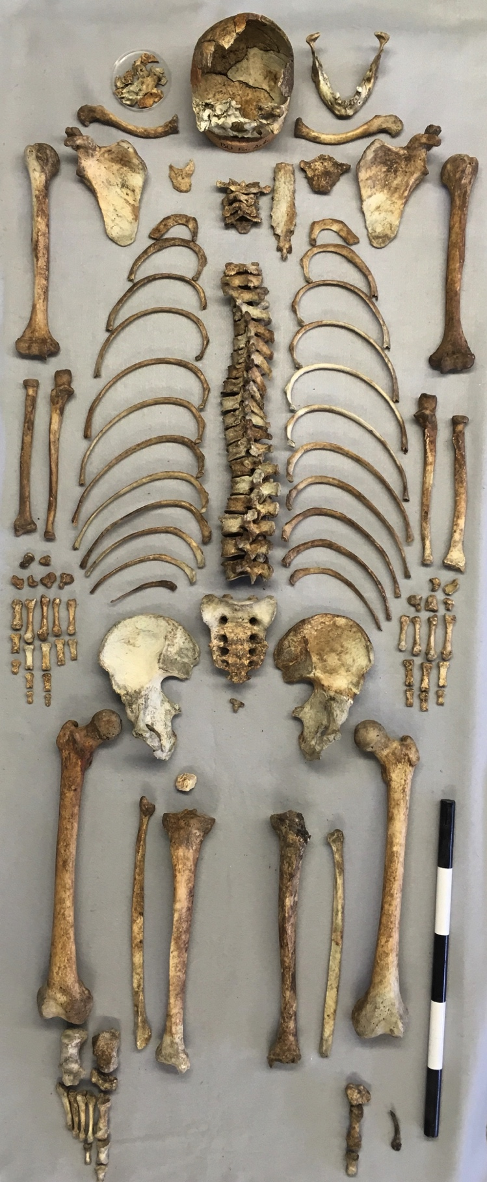

**Figure 1. Skeletal remains of Case BU-35. The scale is in dm.**

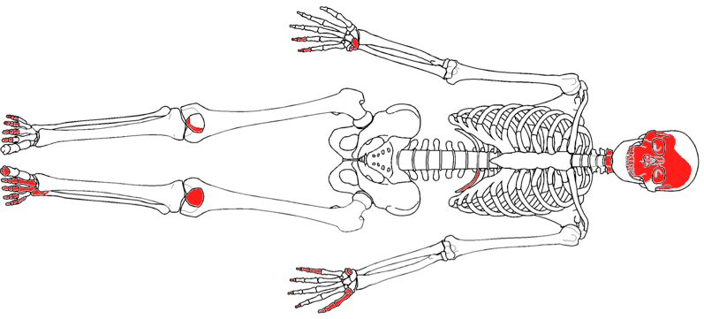

**Figure 2. Skeletal diagram of Case BU-35. Elements in red are present. Seriation of some elements is approximate.**

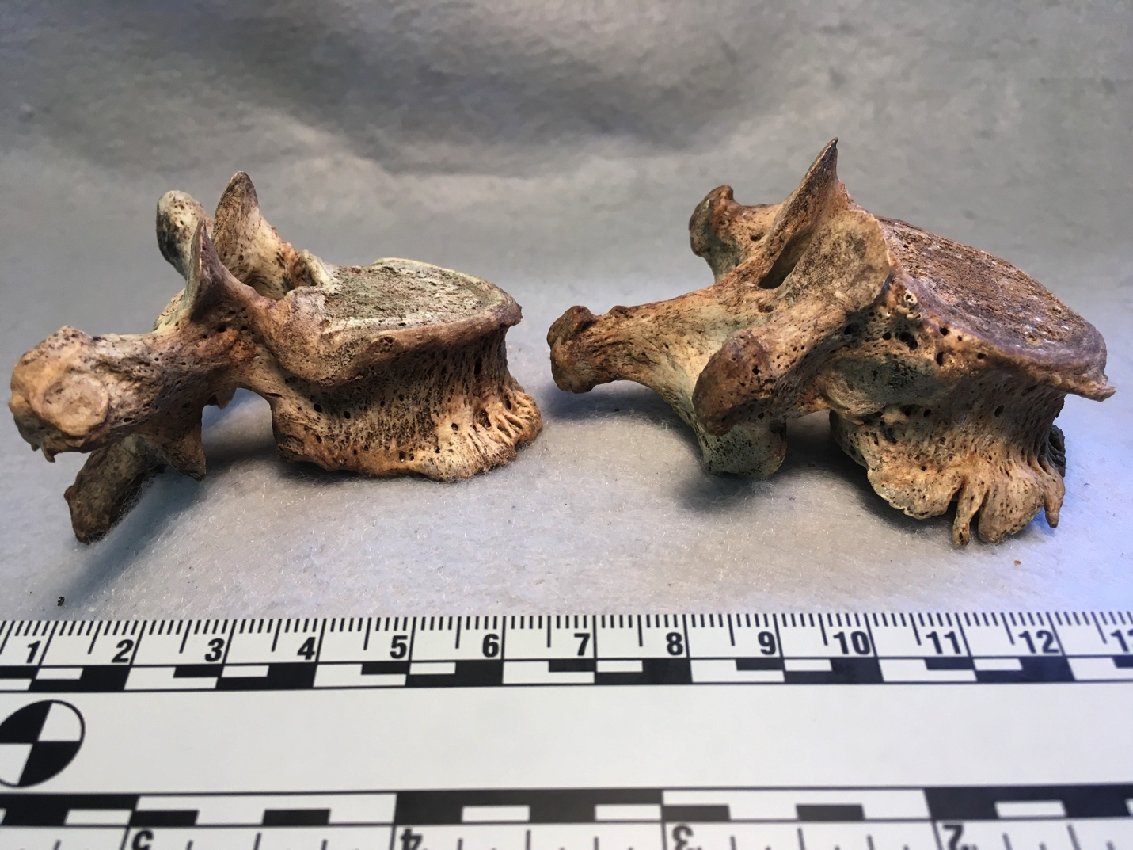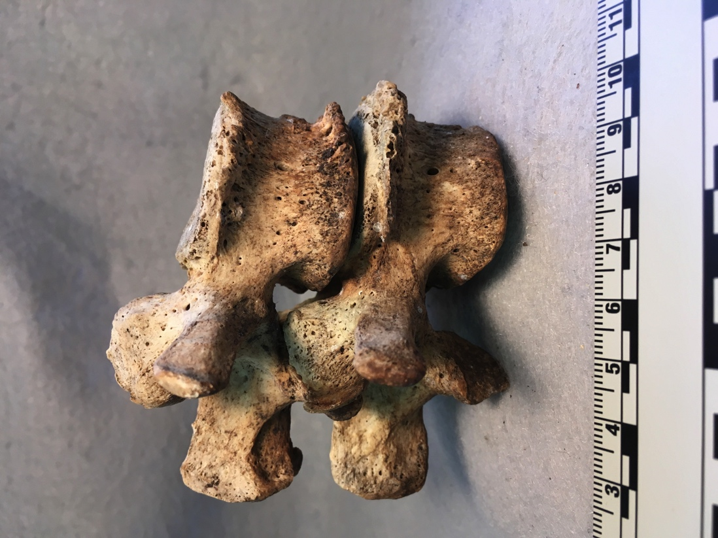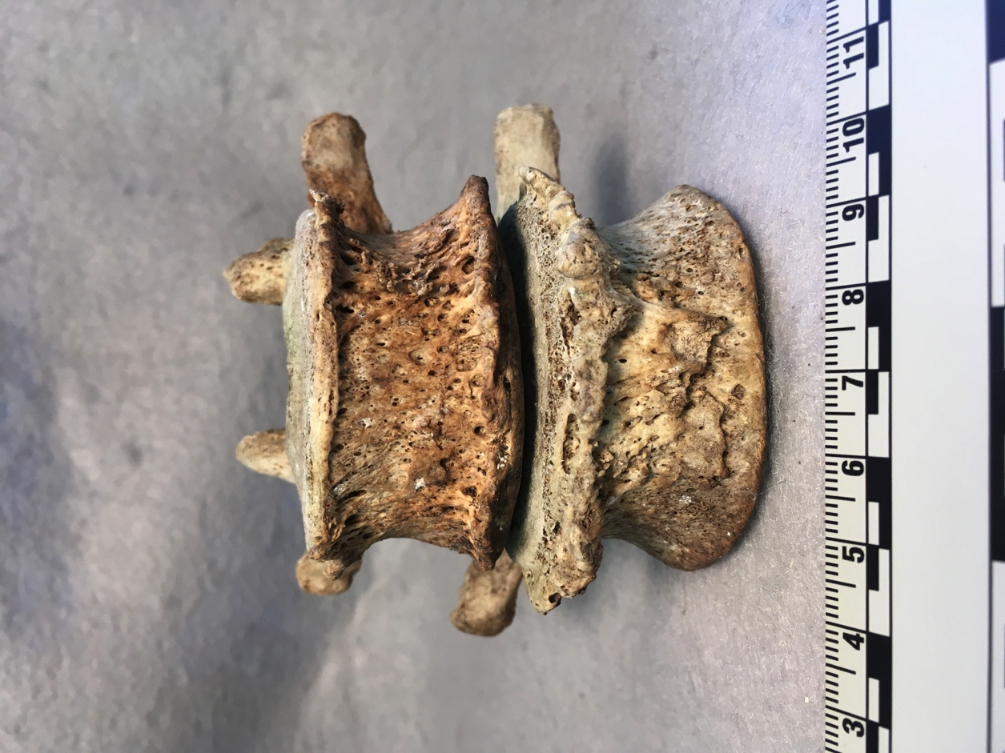

**Figure 3. Antemortem pathological changes to the T7, T11, L2, and L3 vertebrae of Case BU-35. Note the osteophytic lipping on the margins of the vertebral bodies (arrows). The scales are in cm.**

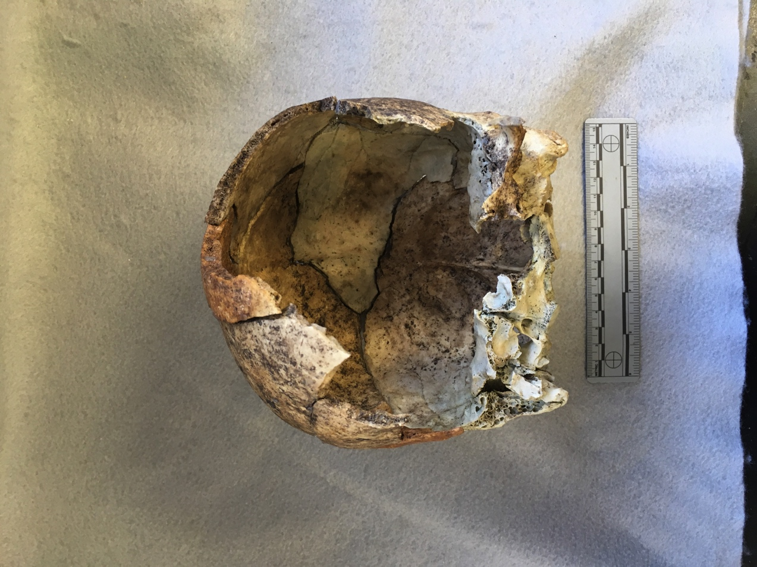

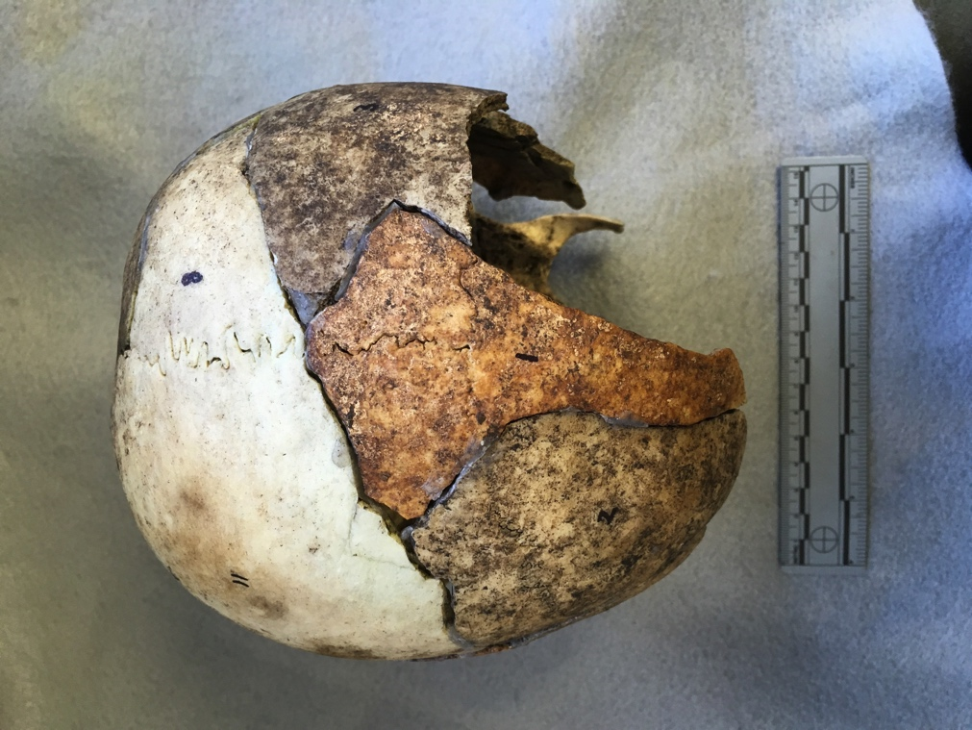

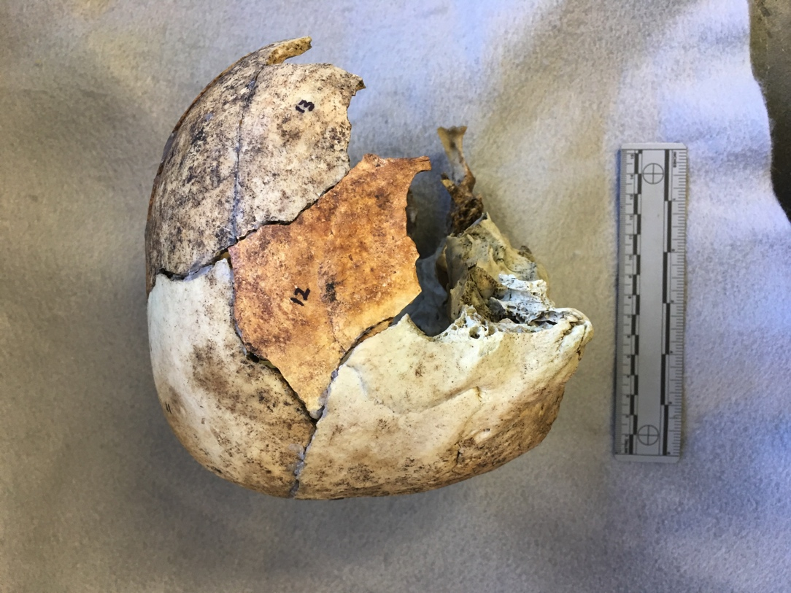

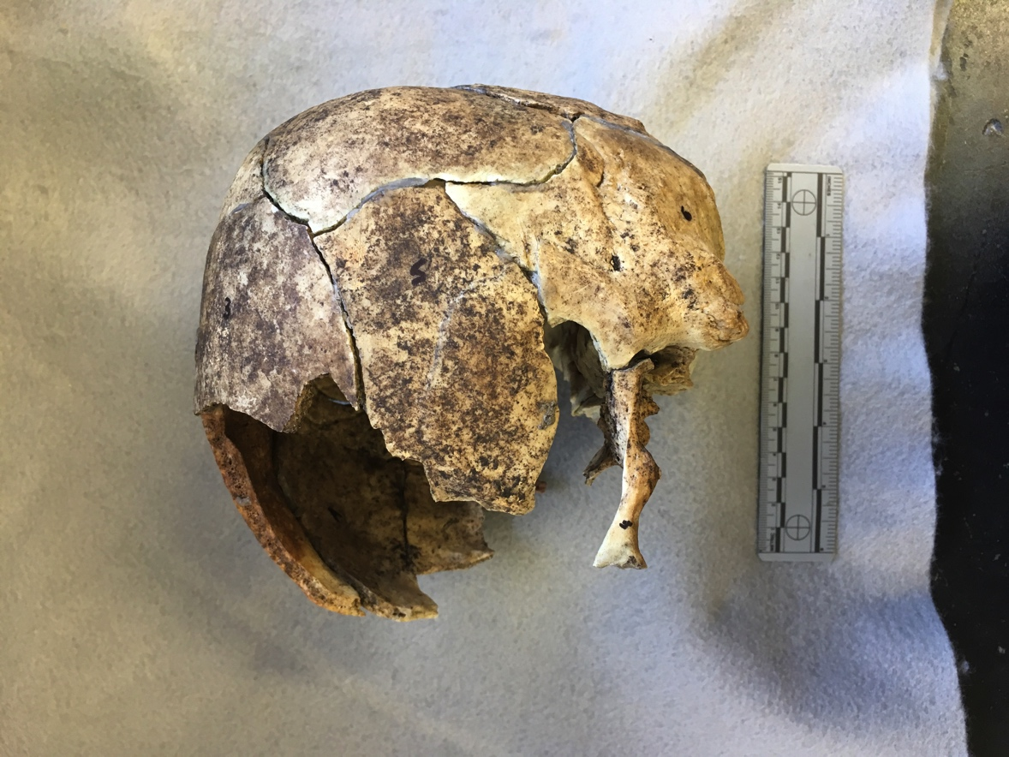

**Figure 4. Perimortem trauma and taphonomic change on the cranium of Case BU-35. Note the extensive fracturing throughout the cranial vault and different coloration of the fragments. The scales are in cm.**

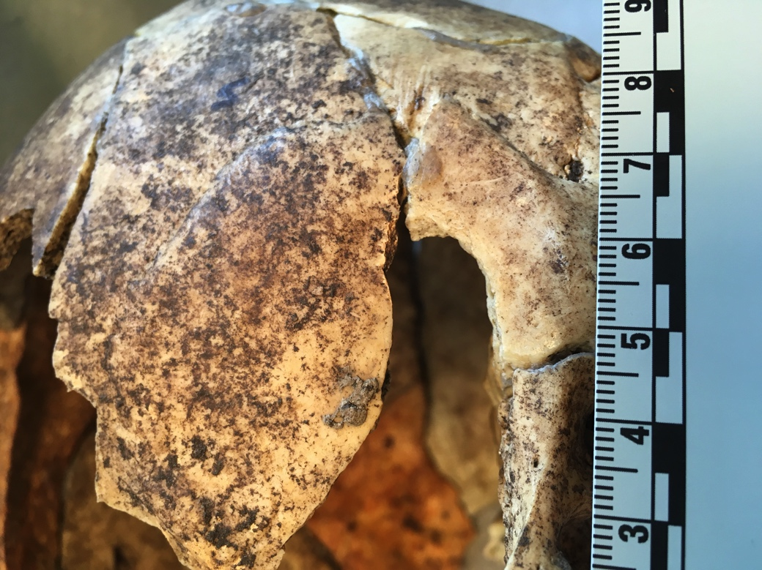

**Figure 5. Perimortem trauma on the cranium of Case BU-35. Note the possible entry wound (arrow). The scale is in cm.**

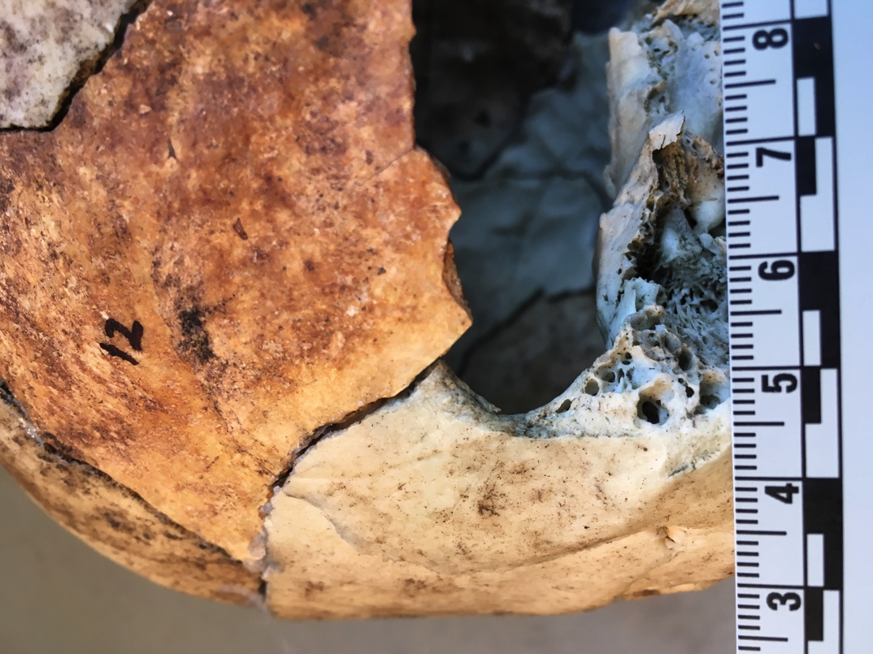

**Figure 6. Perimortem trauma on the cranium of Case BU-35. Note the possible exit wound (arrow), causing external beveling. The scale is in cm.**

**b**

**a**

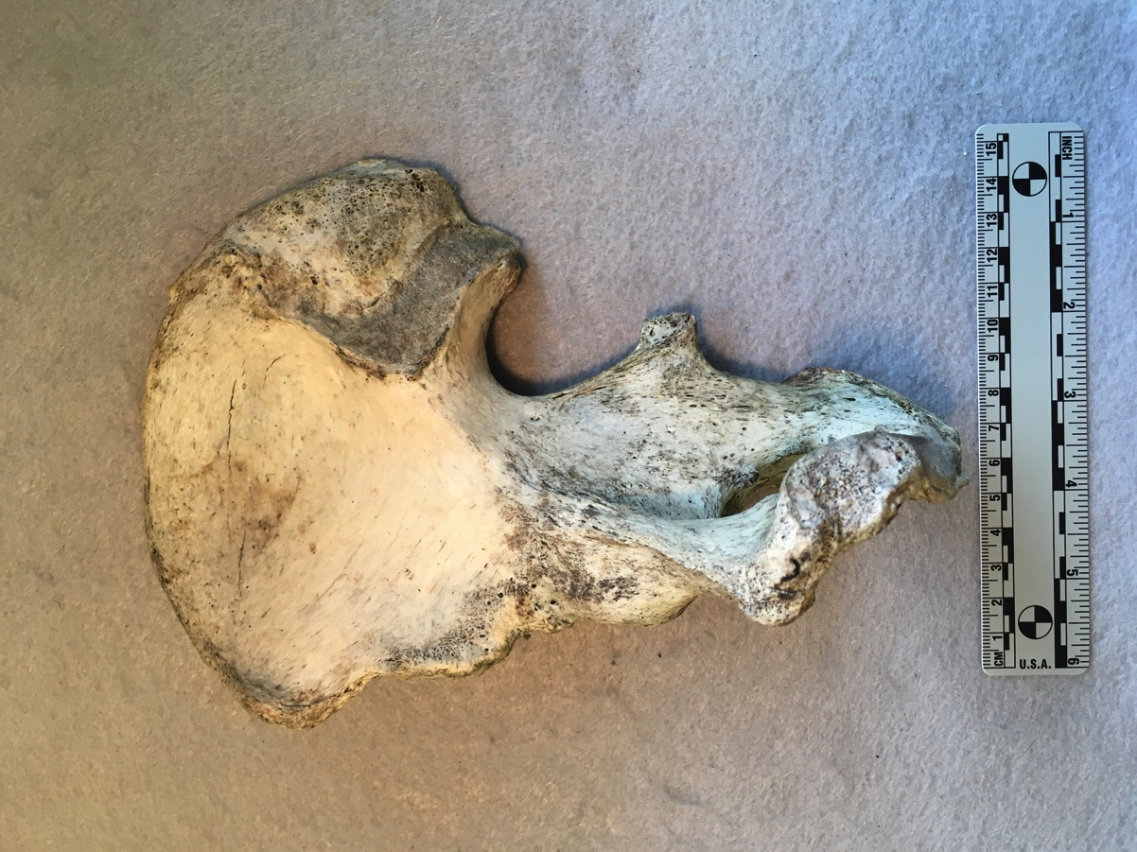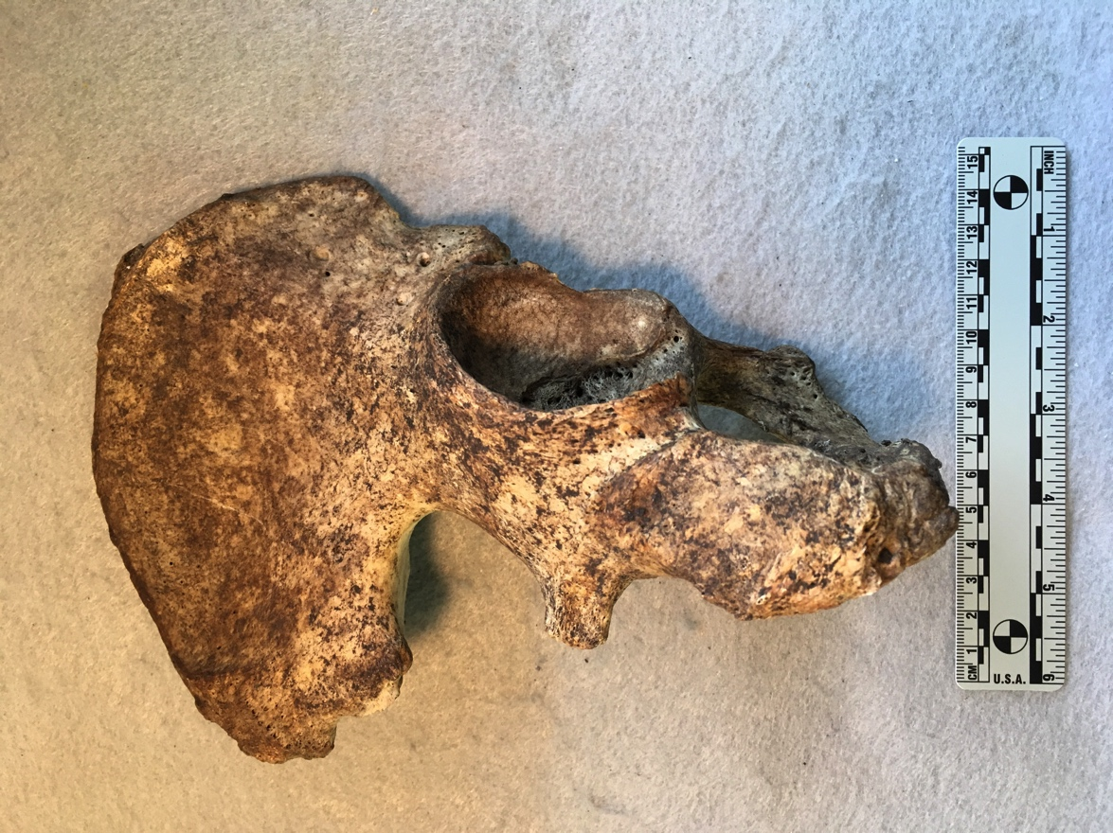

**Figure 7. Example of taphonomic change for Case BU-35. (a) right anterior pelvis showing weathering stage 1 (bleaching and minor cracking); and (b) right posterior pelvis showing dark brown soil staining. Note the difference in staining between the two surfaces of the same element, consistent with surface deposition. The scales are in cm**

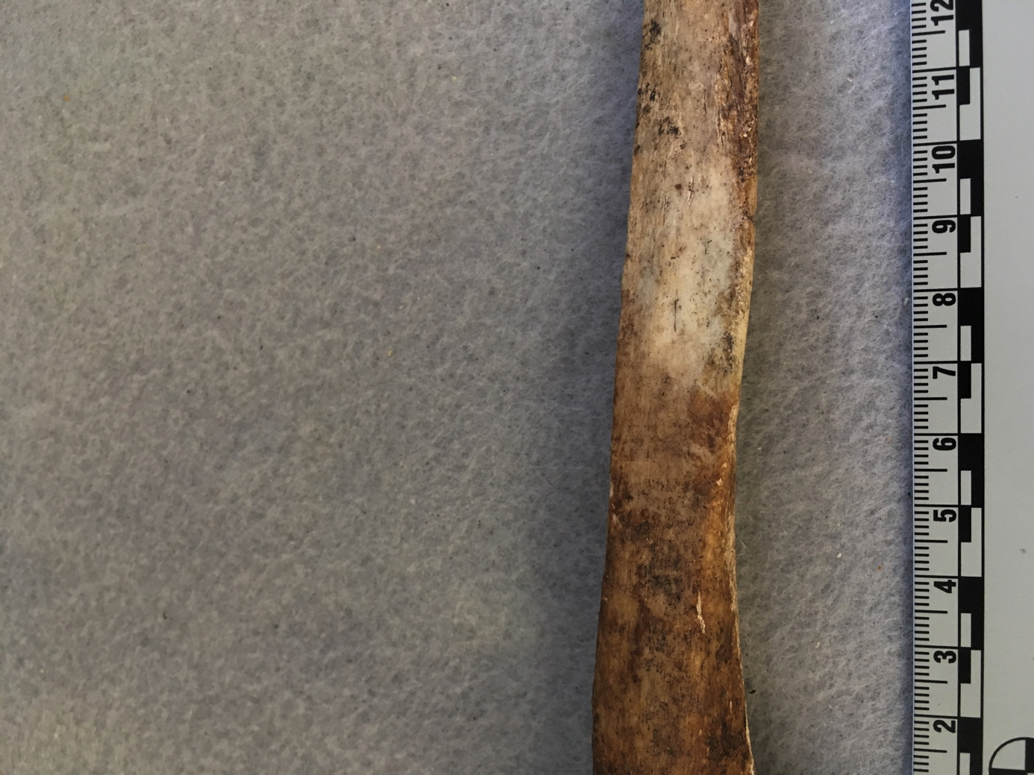

**Figure 8. Example of taphonomic change on the left ulna of Case BU-35. Note the distinct change from bleached to dark brown soil staining (arrow). The scale is in cm.**

**a**

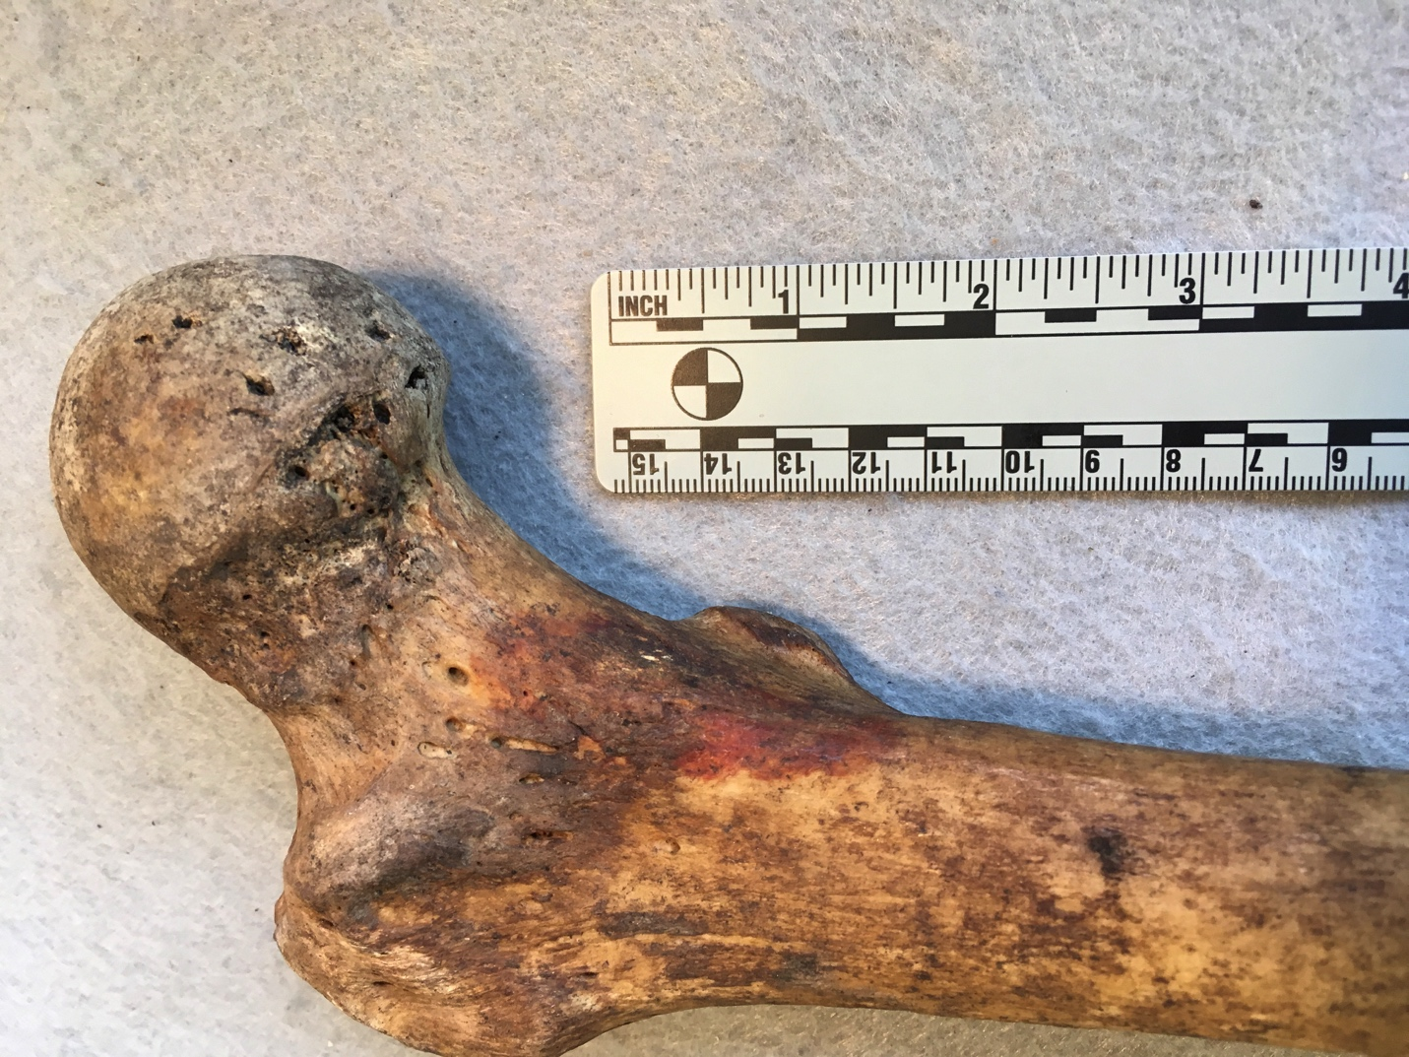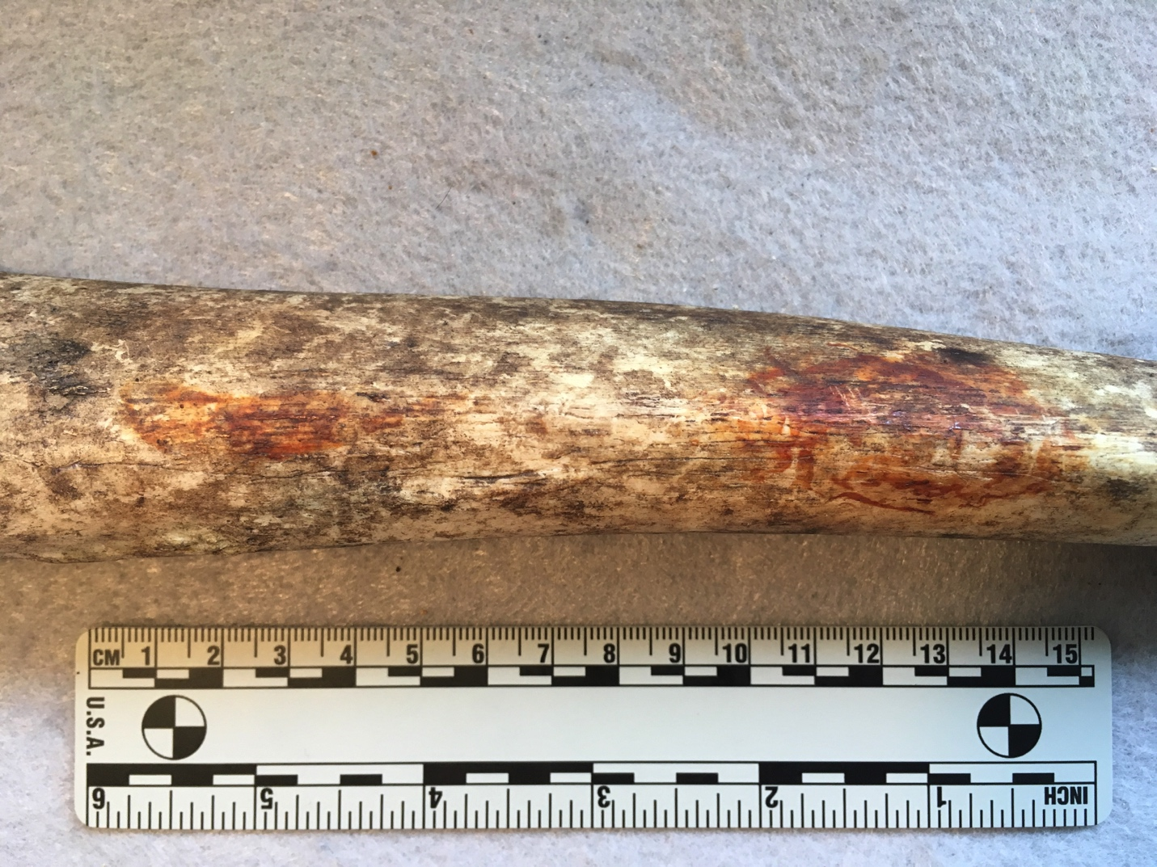

**b**

**Figure 9. Example of taphonomic change for Case BU-35. Note the iron oxide staining (arrows) on the a) midshaft of the left tibia; and b) right proximal femur. The scales are in cm.**

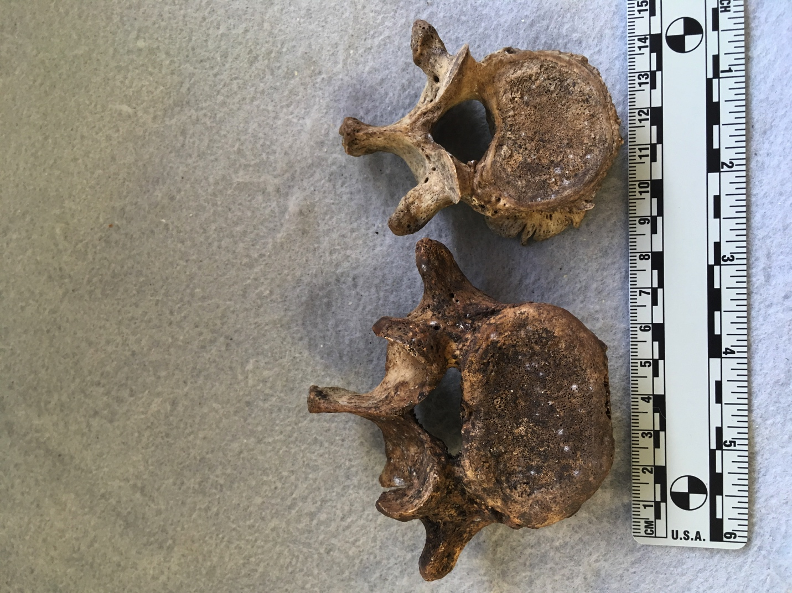

**Figure 10. Example of taphonomic change for Case BU-35. Note the adhering mold on the vertebral bodies of L5, and T11 (arrows). The scale is in cm.**

**b**

**a**

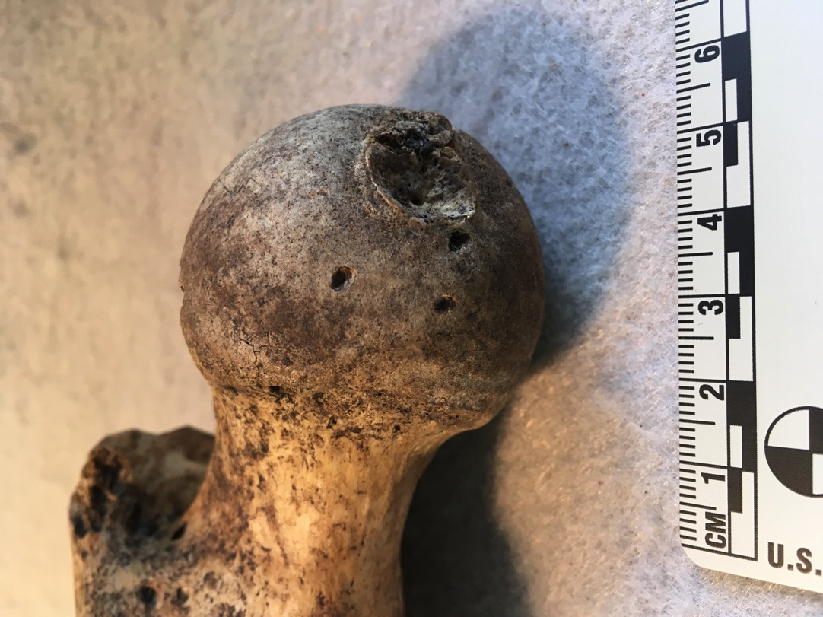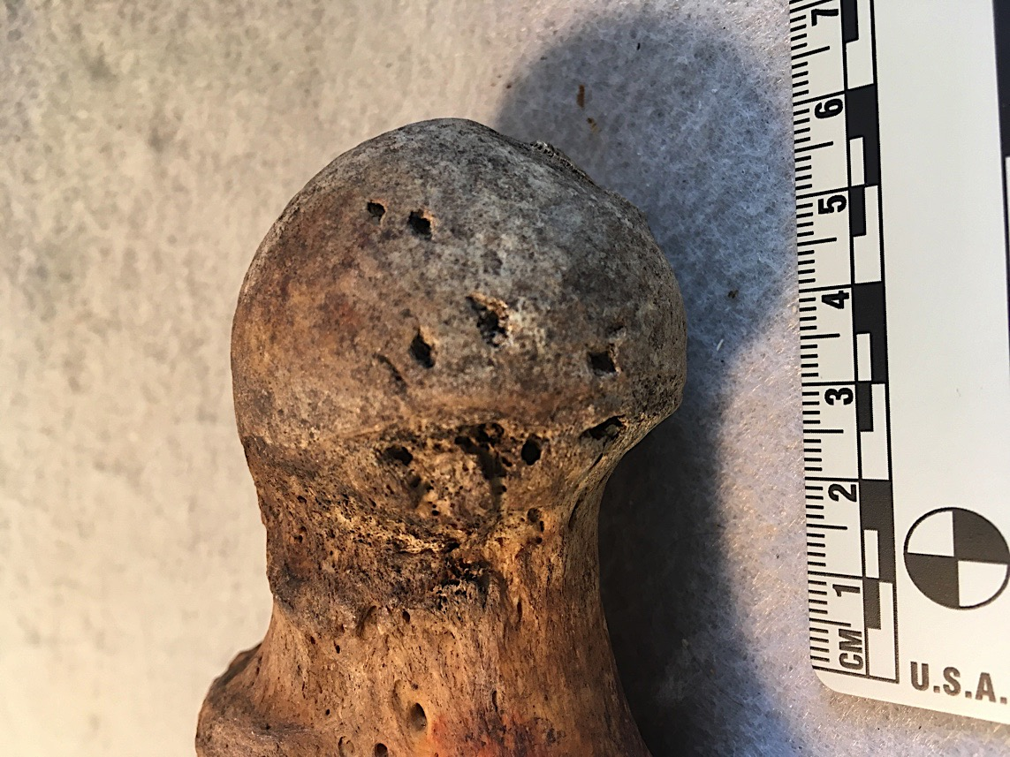

**Figure 11. Example of taphonomic change for Case BU-35. Note the punctures from carnivore gnawing (arrows) on the a) right proximal femur; and b) left proximal femur. The scales are in cm.**

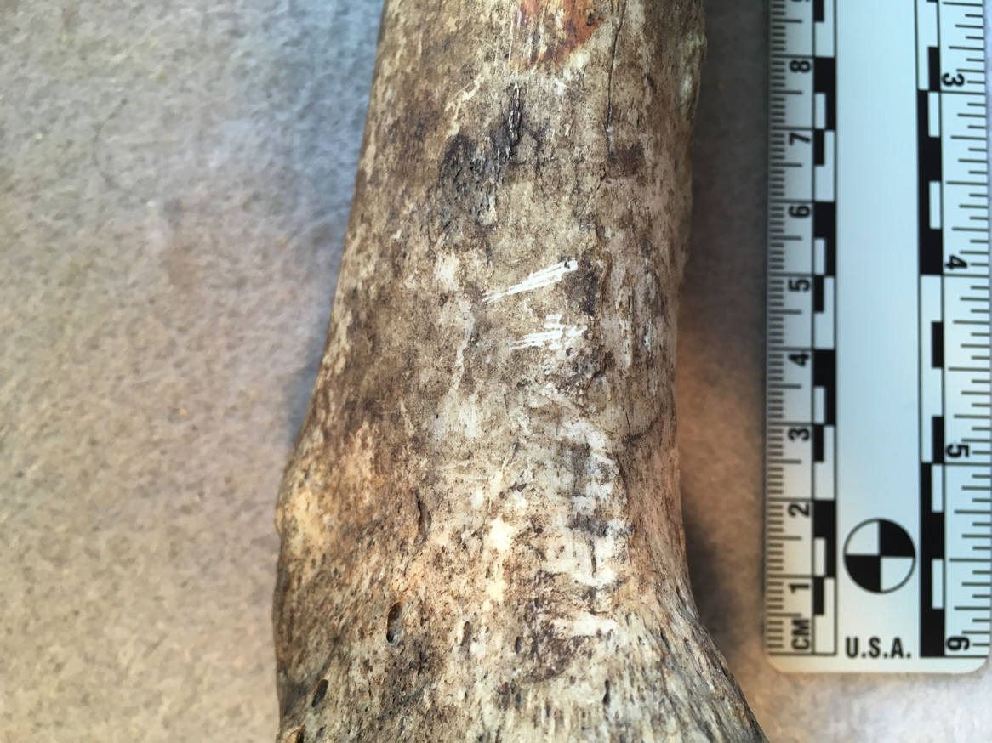

**a**

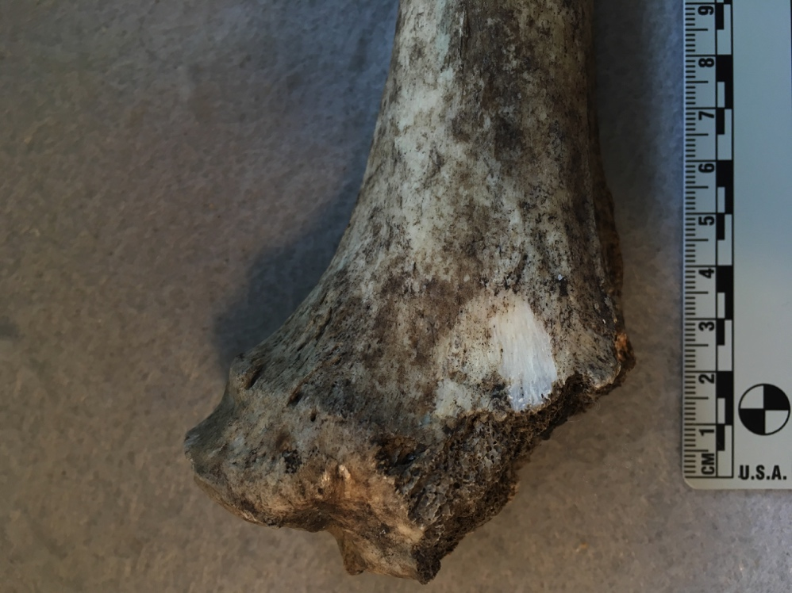

**c**

**b**

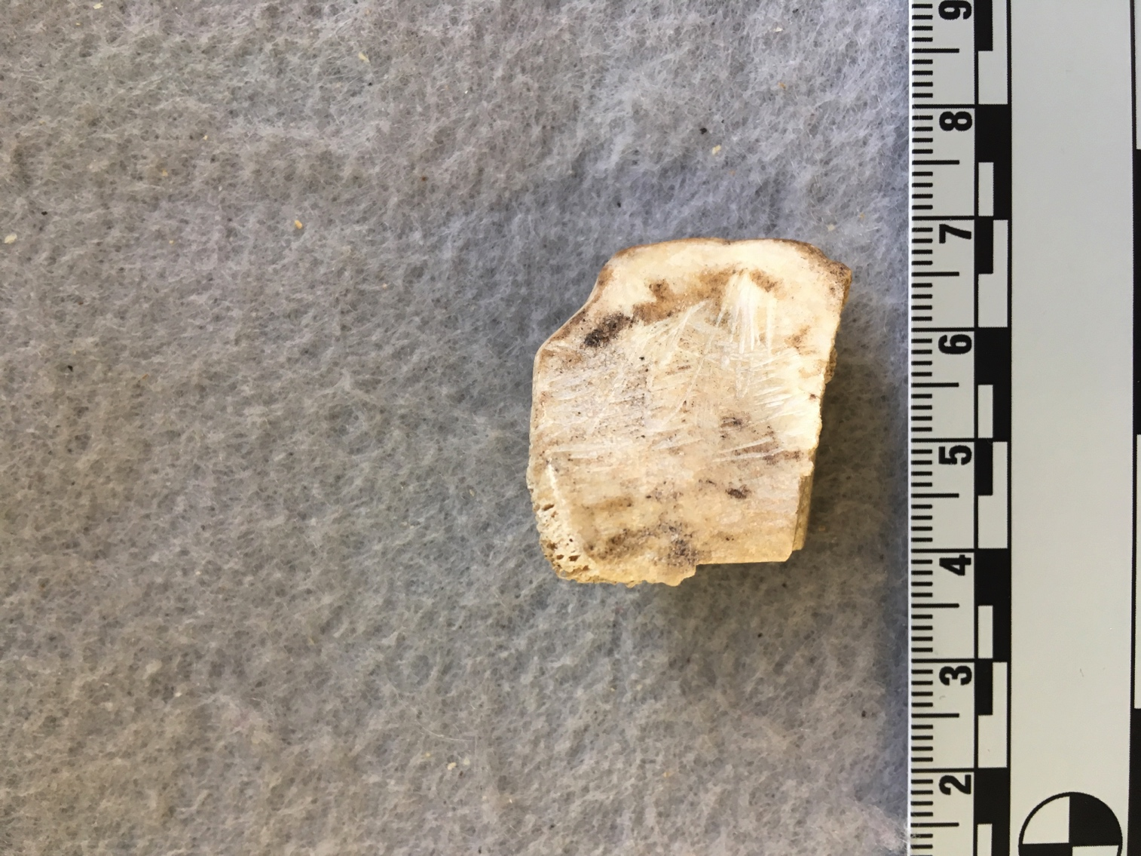

**Figure 12. Example of taphonomic change for Case BU-35. Note the parallel striations from rodent gnawing (arrows) on the a-b) proximal left tibia; and c) right patella. The scales are in cm.**